ANNUAL REPORT
FINANCE AND INVESTMENT CELL
2021-22

The Finance and Investment Cell of Shivaji College is a student – run society, founded in 2019, which aims to impart financial literacy among today’s youth, provide a platform for the financial enthusiasts to get hands-on experience in various fields of finance and shape tomorrow’s financial experts.
Our aim is to spread financial literacy among today’s youth and provide a platform for the brilliant minds to exhibit their financial expertise in order to become more responsible stakeholders in an increasingly globalized economy. We also intend to help the financial enthusiasts reach their designated destination and become a non-stop shop for nurturing the financial entrepreneurial skills of individuals on various financial topics.

Following are members of the cell for academic session 2021-22:

- Dr. Shivani Gupta, Convenor
- Dr. Neetu Rani
- Ms. Urvashi Sahitya
- Mr. Satish Kumar

The council was selected via forms cum interview rounds. A prior preliminary screening was done to lead out the final list of core members for this session.
- PRESIDENT- Sejal Munjal
- VICE PRESIDENTS- Tracy Gupta and Aniket Prasad
- GENERAL SECRETARY- Harshit Talwar
- RESEARCH HEADS- Anmol Aashta and Shreya Maheshwari
- EDITORIAL HEADS- Tanya Rana and Saumya Aggarwal
- CREATIVE AND OPERATIONS HEADS- Diksha Dhoundiyal and Gauri Yadav
- PUBLIC RELATIONS AND MARKETING HEADS- Vanshita Bajaj and Shreya Goyal

Details of the events organized during the academic session 2021-22:

- Personal Finance Webinar Held On 8th September, 2021

The Finance and Investment Cell, Shivaji College organised a webinar on Importance of Personal Finance with Mr. Viraj Nanda, founder and CEO of Globalise on 8th September, 2021.

The webinar focussed on the main fundamental principles of Managing Personal Finances. Mr. Nanda covered a lot of topics starting from what are personal finances to how to start investing in them. Participants were much more clear and interested when he explained with examples why investing in ‘Equities’ is better than investing in ‘FDs’ and why you should start investing at a young age.

The outcome of the webinar was as follows:
* It gave us a basic understanding of what is meant by Personal Finance and how to manage it.
* Participants were able to understand the importance of investing at an young age and came across the ways to start investing.
* We learned how to turn a 10 rupee note into thousands and even lacs.
We witnessed a participation of over 95 students from various colleges and universities.

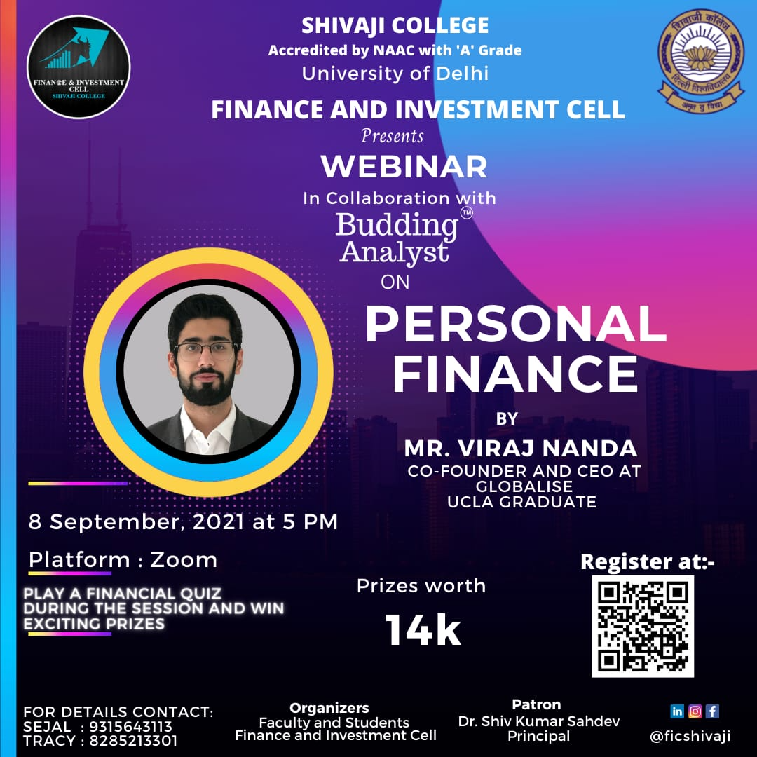

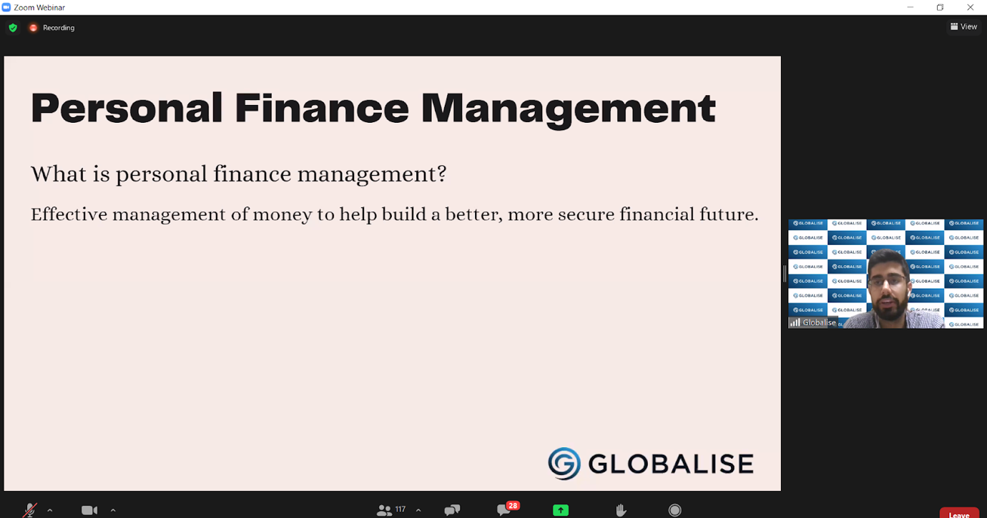

- Brains N Bulls, a Virtual Stock Trading Game held on 20th September to 22nd September 2021

The Finance and Investment Cell, Shivaji College organised ‘Brains N Bulls’, a Virtual Stock Trading Game from 20th September to 22nd September 2021 sponsored by StockGro.

The event aimed to give students hands-on experience of real-life trading and enable the participants to furnish and channelise their stock market skills. It was a 3-day event from 20th September’21 till 22nd September’21.

The outcome of the competition was as follows:
- Participants gained valuable insights as to how the stock market worked and took their first step in the investing world.
- They learnt what stocks to invest in and how to analyse a company’s strength.

The attendees actively participated in the Game and the top winners were awarded kind prizes amounting to ₹7000, sponsored by StockGro. The Game was conducted smoothly without any glitches or troubles.

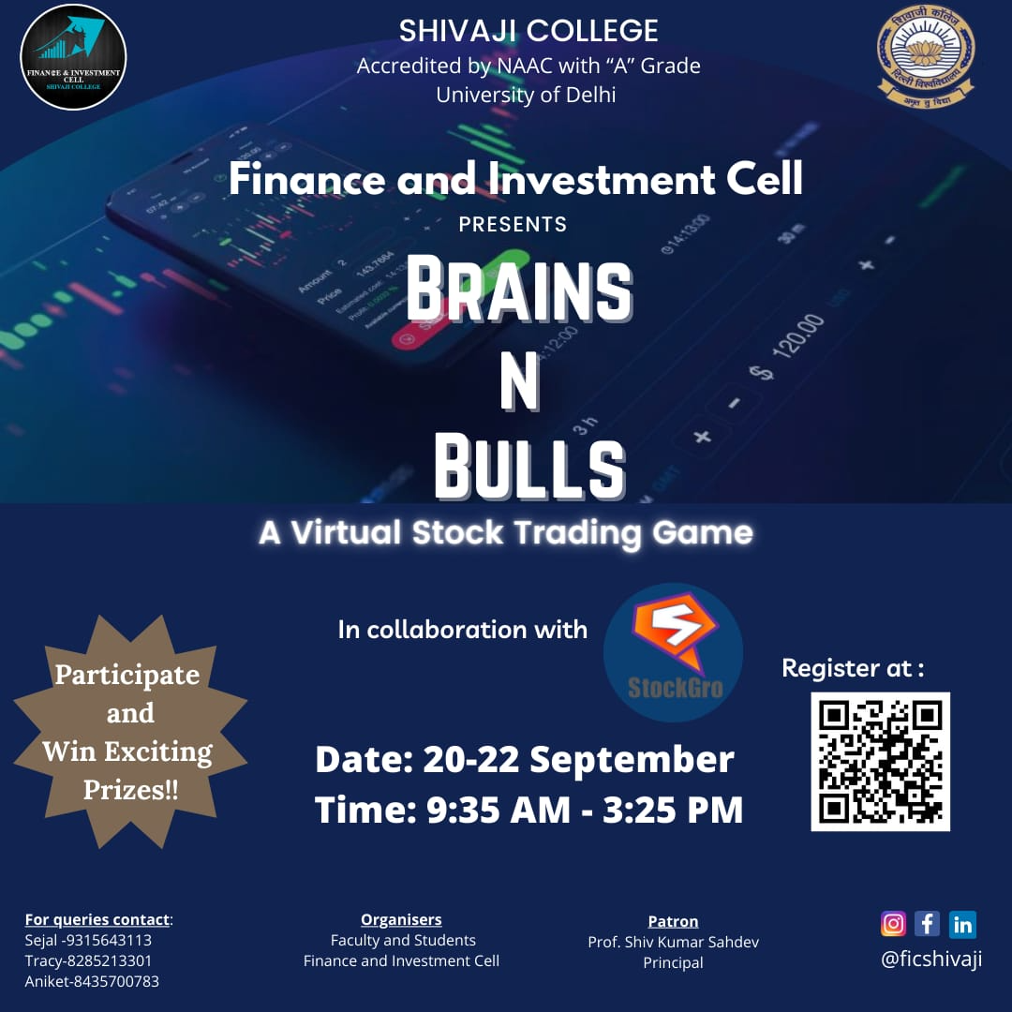

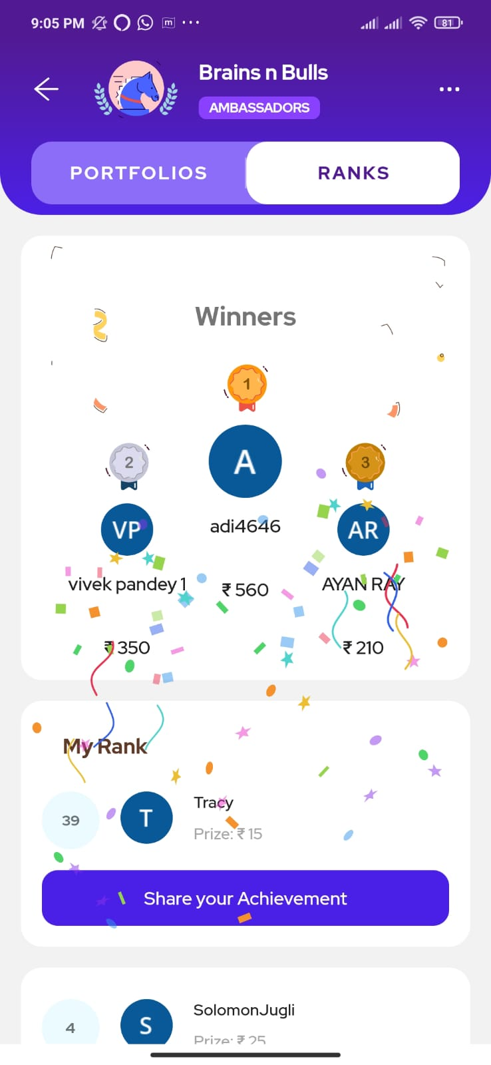
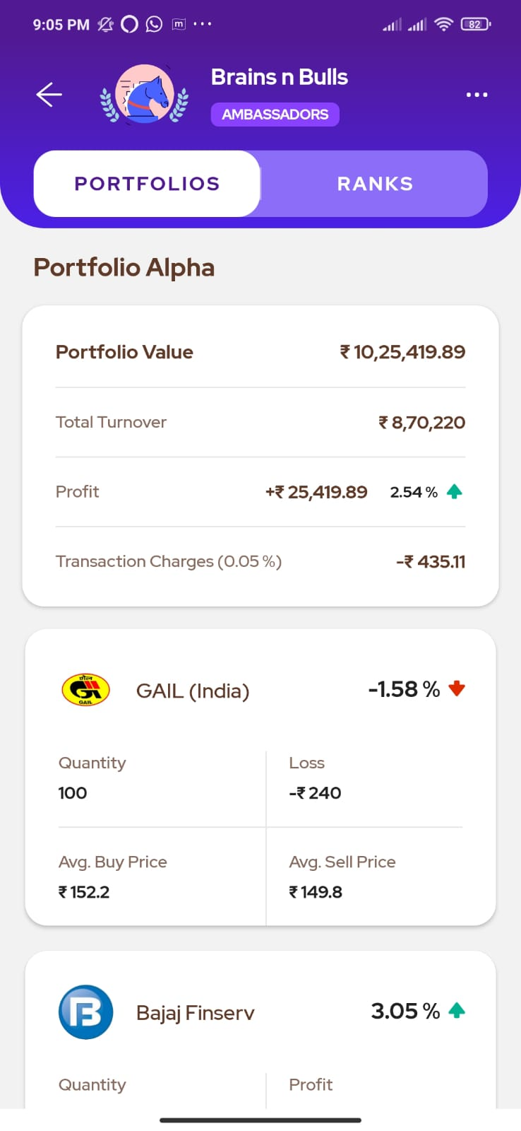

- Investment in Stocks and Crypto webinar conducted on 27th October 2021

The Finance and Investment Cell, Shivaji College organised a webinar on “Investment in Stocks and Crypto” with Mr. Tahem Veer Verma, founder and CEO of Mesha, a PENN graduate on the 27th of October 2021.

The webinar focussed on the basics of crypto and stocks and the market mechanism in both investments. Mr. Verma covered many topics such as the creation of crypto and how it is one of the safest ways to invest. Participants were able to comprehend topics easily and showed sudden enthusiasm when he used the examples of dogecoin and the famous Bitcoin.

The outcome of the webinar was as follows:
- It gave us a basic understanding of what are Stocks and Crypto and why should one invest in them.
- Participants were able to understand the importance of the Time value of money and why investing in stocks and crypto is the best if one has to make profits during inflation.
- We also learned about the safety measures regarding investments in stocks and crypto.

We witnessed the participation of 85 and above students from various colleges and universities. The attendees actively participated in the Questions and Answer round and the session was conducted smoothly without any glitches or problems. We also received an extremely positive response from the participants as observed through the feedback form released after the session. The general opinion seen in the responses was that the webinar was extremely knowledgeable and insightful and the students requested more such webinars based on Investing in Stock Markets and Cryptocurrencies.
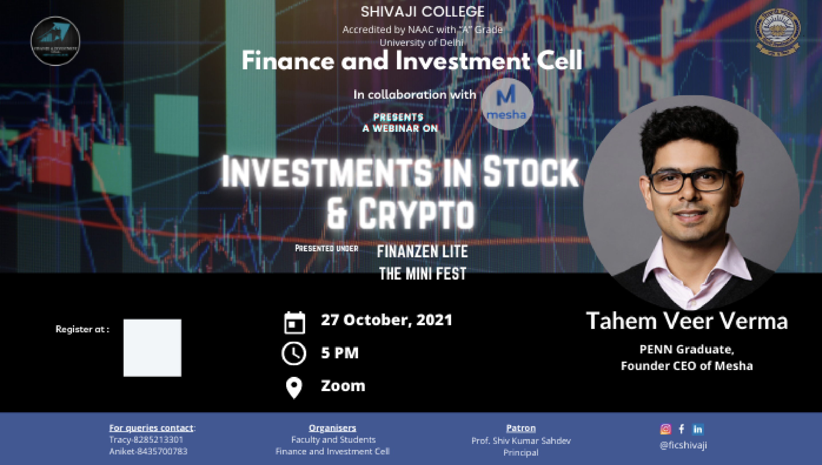
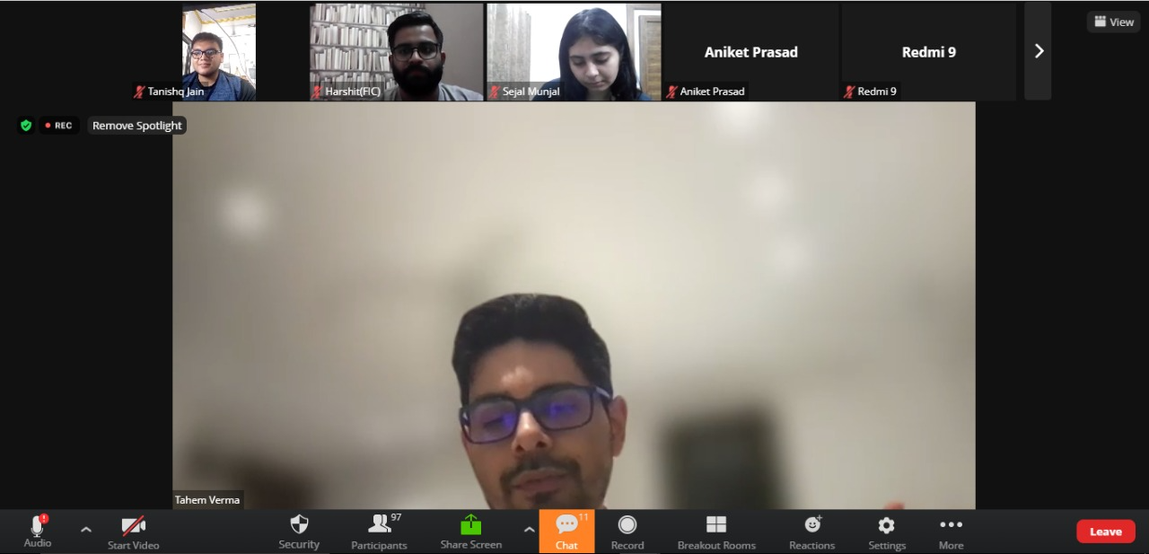
Mock Stock Competition held on 28th October to 29th October 2021

The Finance and Investment Cell, Shivaji College organized the ‘Mock Stock Competition ’, a virtual stock simulation that brings to you Finanzen Lite, the Mini-Fest from 28th October to 29th October 2021 sponsored by Mesha.

The event aimed to give students hands-on experience of stock simulation and enable the participants to furnish and channelize their stock market skills. It was a 2-day event from 28th October till 29th October ’21 and on 29 the October quiz was organized on Mesha App. I

The outcome of the competition was as follows:
- Participants gained valuable insights as to how the stock market worked and took their first step in the investing world.
- They learned what stocks to invest in and how to analyze a company’s strength and to make maximum percentage return on the initial portfolio value.

It had received massive registrations of 170+ students from more than 50 colleges and universities from all over India. It was stand-alone sufficient to display the reach and influence of the society. The attendees actively participated in the Competition and the top winners were awarded kind prizes amounting to ₹1000 sponsored by Mesha. The Competition was conducted smoothly without any glitches or troubles.

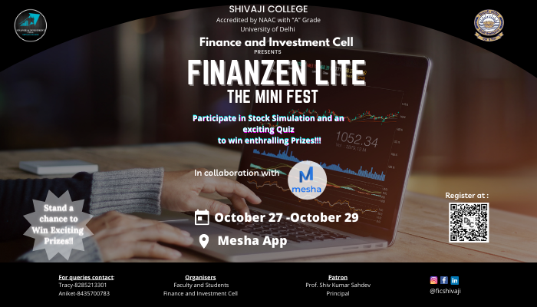

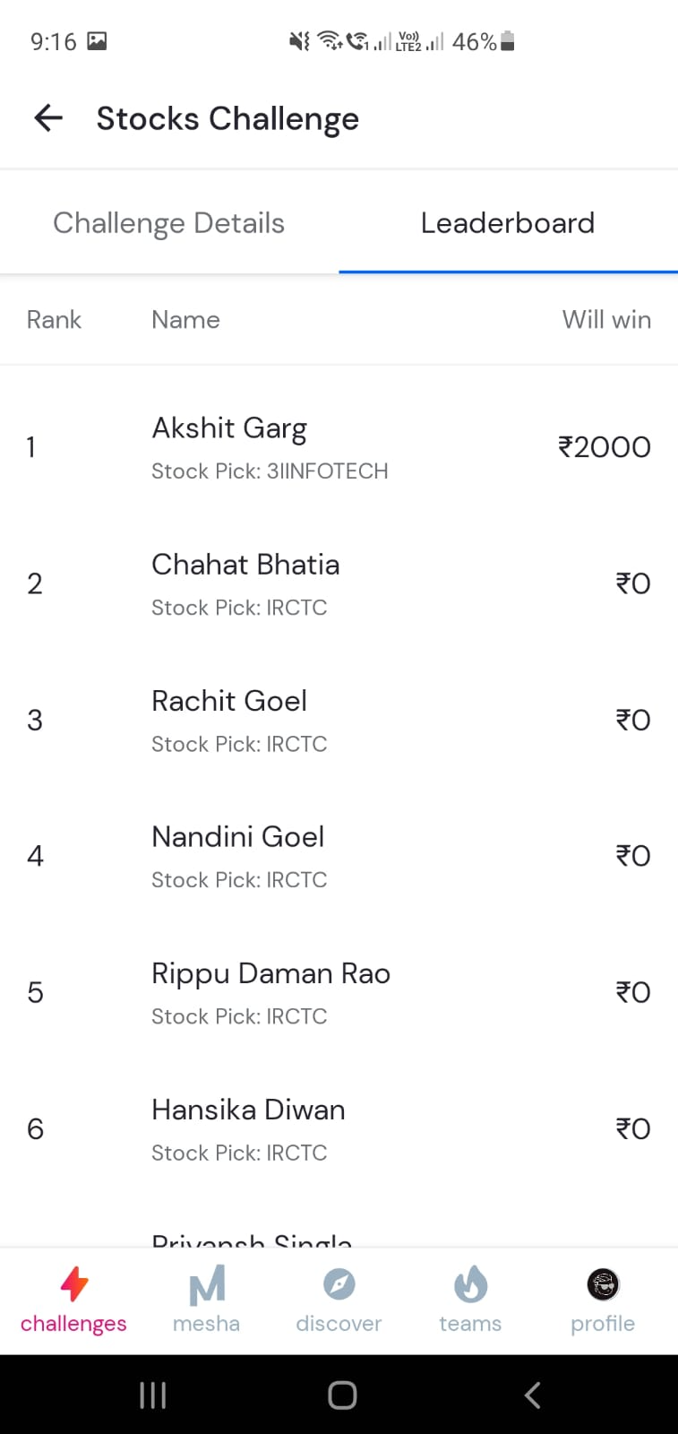

- Careers in Finance webinar conducted on 2nd February 2022
The Finance and Investment Cell, Shivaji College hosted a webinar on “Careers in Finance” on 2nd February, 2022 via ZOOM. It was taken by Mr. Aswini Bajaj, CEO of Leveraged Growth. Over 150 students from various colleges took part in the event.
As scheduled, the event kicked up at 4:30 p.m. with a formal introduction by the host wherein she extended a warm welcome to all those present. Then, the convener, Dr. Shivani Gupta took the charge and welcomed the guest speaker with an introduction detailing his credentials, work and accomplishments.
Following which, Mr. Aswini Bajaj took over. He divided the entire event into two sections:
- What is Finance?
- Different courses related to finance
Using realistic examples from real-life scenarios, he addressed all of the essential concept in finance during the webinar, including quants, economics, financial report analysing, corporate finance, equities, derivatives and ethics.
He also discussed in detail important courses in the field of finance, such as CFA, FRM, and many more. The audience demonstrated their comprehension and passion by enthusiastically engaging in the Q&A session, during which the speaker answered the majority of their questions. The workshop went through without a hitch, and it was a great learning experience for all of the financial aficionados.
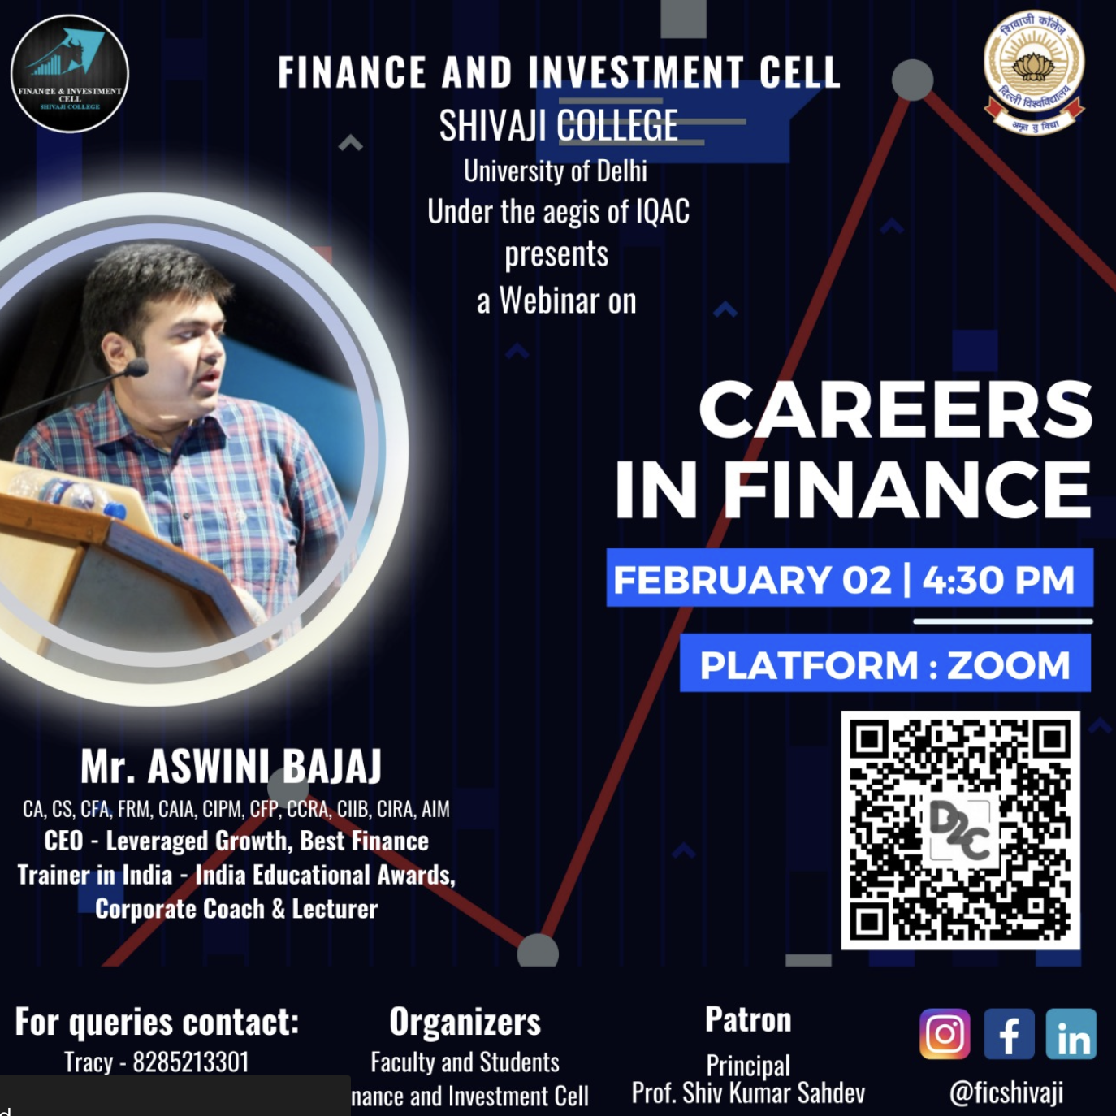

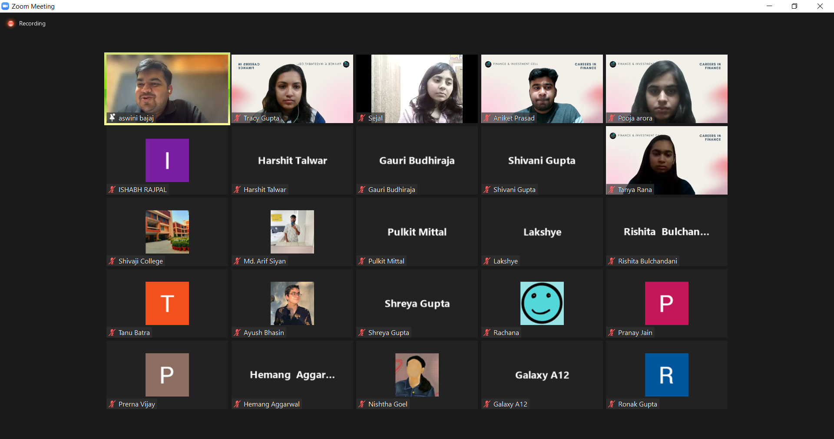
5) Annual Festival - FINANZEN-2022 held on 5 March 2022
The Finance and Investment Society at Shivaji College held their annual fest "FINANZEN 2022" online on March 5, 2022. The fest had six amazing competitions along with an insightful webinar to provide students with loads of knowledge along with some competitive spirit.
FINANZEN 2022 was kicked start with an insightful webinar on Insurance Growth in India. Mr. Dinesh Chandra Khansili, Former Executive Director of the Institute of Actuaries of India, accepted the position. As scheduled, it began at 11 a.m. with a warm greeting from the host, followed by the incisive words of the respected principal Prof. Shiv Kumar Sahdev. The speaker began with an introduction to himself, including his personal path, in which he highlighted the reality that each individual is unique. Followed by this, he discussed the state of the insurance industry in the 2000s. He summed up his session by underlining the fact that the insurance sector is growing day by day. Following the webinar, six competitions were held, which comprised quizzes, trading, and problem-solving to put the financial aficionados to the test.
